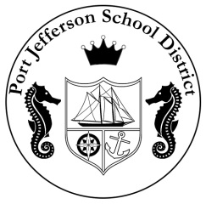
Port Jefferson School District
office of MUSIC & FINE ARTS
350 Old Post Road
Port Jefferson, NY 11777
Phone (631)791-4450 Fax (631)476-4408

Paul Casciano, Ed.D. Michael Caravello, Ed. D.
Superintendent of Schools Director of Music and Fine Arts

September 7, 2018

Dear Student and Parents,

Welcome back! I hope you and your families have had an enjoyable summer and are looking forward to another exciting and productive musical year!

Attached are the 6th Grade Orchestra Policies and your child’s lesson schedule. Please read the material with your child and contact me with any questions or concerns. All lessons will meet on Fridays and orchestra will meet Period 4 on “B” and “D” days. Lessons will begin Friday, September 21st.

Cellos and bass are ready for pick-up. Please email ahead with the day you plan to pick-up your child’s instrument and I will have it tuned and ready for you at the front security desk in the gym lobby. A reminder also violas will no longer be provided by the school and should be rented by the student. Please let me know if you have any questions regarding where to rent a viola.

For additional information, I invite you to view our classroom website at: www.salzmanorchestra.weebly.com
We will also be utilizing Google Classroom and Google Sites for various assignments throughout the year. Feel free to contact me at any time with your questions or concerns. Please let me know if you are not receiving my emails or if you would like to add an email address. Most of the correspondence for this class will be sent electronically. I look forward to sharing an enriching school year with you and your children.

Sincerely,

Vanessa Salzman, D.M.A.
4-6 Orchestra Teacher
Port Jefferson School District
631.791.4300, x1519
vsalzman@portjeffschools.org

